**19-01-2018**

**RESEARCH INFOTECH**

**DAILY ANALYSIS**

|  |
| --- |
| http://researchinfotech.co.in/storage/images/logo.pngImage result for SEBI |

|  |
| --- |
| **RELCAPITAL (RELCAPITAL) (NSE Cash)** |

|  |  |  |
| --- | --- | --- |
| **BUY** | **500-501** | **SL-480** |
| **TGT 1- 535** | **TGT 2- 580** | **SL-480** |

|  |  |  |  |  |
| --- | --- | --- | --- | --- |
| **S1** | **S2** | **PP** | **R1** | **R2** |
| **535** | **540** | **560** | **575** | **610** |

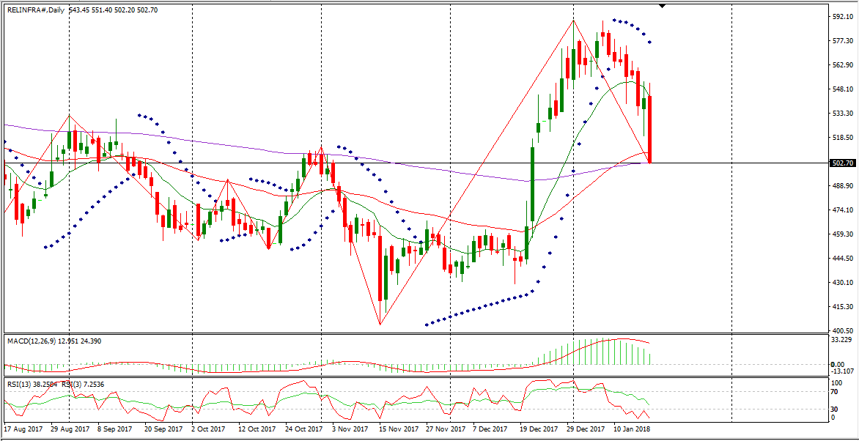

**DESCRIPTION**

Reliance Infrastructure Limited (RInfra) is involved in the infrastructure sector. The Company is a utility company with presence across the chain of power businesses, such as generation, transmission, distribution and power trading. RInfra operates through two segments: Power, and Engineering, Procurement, Construction (EPC) and Contracts. The Company, through Power segment, operates 500-megawatt Thermal Power Station at Dahanu, 220-megawatt combined cycle power plant at Samalkot, 48-megawatt combined cycle power plant at Mormugao, 9.39-megawatt Windfarm at Chitradurga, and also purchases power from third parties and supplies the power through its own distribution grid. The EPC and Contracts segment renders services in construction, erection and commissioning. RInfra's projects include coal based thermal power projects, gas based combined cycle power projects, solar photo-voltaic and solar thermal, hydro-electric power projects, co-generation plants and rural electrification works.

|  |
| --- |
| http://researchinfotech.co.in/storage/images/logo.pngImage result for SEBI |

**TECHNICAL VIEW**

* In daily candle RELINFRA was looking strong, it was taking support of its 200 day’s EMA and looking bullish.
* From the opening it was falling down but in 15 minute candle stick, it took support of its short term moving avg and I saw fresh buying near closing.
* Near closing I saw huge OI in RELINFRA also.
* In daily candle it was taking suppport of its day’s low also

**RECENT NEWS**

* Volume Moving the Tape -0.30% For Reliance Infrastructure Limited (RELINFRA.NS)
* Shares of Reliance Infrastructure Limited (RELINFRA.NS) are moving on volatility today -0.30% or -1.65 from the open. The NSE listed company saw a recent bid of 542.30 and 766720 shares have traded hands in the session.
* The RSI, or Relative Strength Index, is a widely used technical momentum indicator that compares price movement over time. The RSI was created by J. Welles Wilder who was striving to measure whether or not a stock was overbought or oversold. The RSI may be useful for spotting abnormal price activity and volatility. The RSI oscillates on a scale from 0 to 100. The normal reading of a stock will fall in the range of 30 to 70. A reading over 70 would indicate that the stock is overbought, and possibly overvalued. A reading under 30 may indicate that the stock is oversold, and possibly undervalued. After a recent check, Reliance Infrastructure Limited’s 14-day RSI is currently at 54.64, the 7-day stands at 42.70, and the 3-day is sitting at 31.20.

## **DISCLOSURE**

RESEARCH INFOTECH DO NOT RECEIVE ANY CONSIDERATION BY WAY OF REMUNERATION OR COMPENSATION OR IN ANY OTHER FORM WHATSOEVER, BY US OR ANY OF OUR ASSOCIATES OR SUBSIDIARIES FOR ANY DISTRIBUTION OR EXECUTION SERVICES IN RESPECT OF THE PRODUCTS OR SECURITIES FOR WHICH THE INVESTMENT ADVICE IS PROVIDED TO THE CLIENT.

RESEARCH INFOTECH DO NOT RECOMMEND A STOCK/COMMODITY BROKER. IF ANY STOCK/COMMODITY BROKER IS RECOMMENDED BY ANY OF OUR REPRESENTATIVE, WE DO NOT RECEIVE ANY CONSIDERATION BY WAY OF REMUNERATION OR COMPENSATION OR IN ANY OTHER FORM WHATSOEVER FROM STOCK/COMMODITY BROKER OR ANY OTHER INTERMEDIARY SO RECOMMENDED TO CLIENT.

TO ENSURE COMPLIANCE WITH THE INVESTMENT ADVISOR REGULATIONS 2013, WE HAVE RESOLVED THAT THE INVESTMENT ADVISOR AND ALL ITS REPRESENTATIVES WILL NOT MAKE ANY TRADES IN THE MARKET. WE ARE NOT ASSOCIATED IN ANY MANNER WITH ANY ISSUER OF PRODUCTS/ SECURITIES, THIS ENSURES THAT THERE IS NO ACTUAL OR POTENTIAL CONFLICTS OF INTEREST. THIS ALSO ENSURES THAT OBJECTIVITY OR INDEPENDENCE IN THE CARRYING ON OF INVESTMENT ADVISORY SERVICES IS NOT COMPROMISED. INVESTMENT IN STOCK/COMMODITY MARKETS IS SUBJECT TO MARKET RISK, THOUGH BEST ATTEMPTS ARE MADE FOR PREDICTING MARKETS, BUT NO SURETY OF RETURN OR ACCURACY OF ANY KIND IS GUARANTEED, WHILE THE PERFORMANCE SHEET OF VARIOUS PRODUCTS IS AVAILABLE BUT SHOULD NOT BE CONSIDERED AS A GUARANTEE FOR FUTURE PERFORMANCE OF THE PRODUCTS/SERVICES. CLIENTS ARE ADVISED TO CONSIDER ALL THE ADVICE AS JUST AN OPINION AND MAKE INVESTMENT DECISION ON THEIR OWN.

IN CASE OF CLIENTS SEEKING ADVICE ON ANY SPECIFIC POSITIONS ALREADY MADE BY THE CLIENT, WE WILL BE ABLE TO SUGGEST BEST POSSIBLE ACTION CONSIDERING OUR VIEW ON THE SECURITY OR PRODUCT. SUCH SUGGESTION UNDER ANY CIRCUMSTANCES SHALL BE CONSIDERED AS AN OPINION (NOT ADVICE) FROM OUR ORGANIZATION AND WE ADVISE CLIENT TO CONSIDER OUR OPINION AND NOT CONSULTANCY TO MAKE HIS/HER FINAL DECISION. WE ARE NOT LIABLE FOR ANY LOSSES WHATSOEVER CLIENT MAY INCUR IN ACCEPTING THIS OPINION.

CLIENT IS ALSO ADVISED TO TRADE ONLY IF TIPS SUIT HIS CURRENT RISK APPETITE AND RISK BEARING CAPACITY, ALL SUCH TIPS SHALL BE CONSIDERED AS A VIEW OR OPINION AND CLIENT SHALL ON HIS/HER DISCRETION DECIDE ACTUAL TRADES.

WE ARE NOT ASSOCIATED WITH ANY INTERMEDIARIES AND DO NOT RECOMMEND SERVICES OF ANY SPECIFIC INTERMEDIARIES.  
NO LITIGATIONS HAVE BEEN FILED AGAINST US SINCE THE INCORPORATION.

ALL THE TIPS WHICH ARE SUGGESTED BY US ARE COMMUNICATED IN WRITTEN, NO VERBAL COMMUNICATION FROM ANY OF THE EXECUTIVES OR OTHERWISE UNDER ANY CIRCUMSTANCES SHALL BE CONSIDERED AS ADVICE BY OUR ORGANIZATION.